**EMPETZ**

**SRS DOCUMENT**

**Submitted by**

**Limy Sebastian**

**TABLE OF CONTENTS**

**Introduction** 3

Purpose 4

Scope 5

Objectives 6

**Functional** **Requirements** 7

Primary actors of the system 8

Use case diagram 9

User stories 11

Business process diagram 13

**Non-Functional Requirements** 14

**Technical Requirements** 16

**Conclusion** 17

**Empetz**

**Introduction**

My app **Empetz** could be a comprehensive platform for buying and selling pets, with features that cater to both buyers and sellers. Users can browse and post pet listings with detailed descriptions, images, and pricing, while advanced search filters help buyers find the right pet based on breed, age, location, and other criteria. The app would include a secure messaging system for direct communication, as well as voice and video calling capabilities for a more personalized interaction. A secure payment gateway could handle transactions, with options for escrow services to ensure both parties are protected. Additionally, the app could offer resources on pet care, adoption options from shelters, and tips for responsible pet ownership. Sellers could gain visibility through premium listings, while buyers could receive notifications friendly interface and strong security measures, your app would not only simplify the pet buying and selling process but also promote responsible pet adoption and care.

Clearly defining system requirements is crucial for the successful development and implementation of **Empetz**, as it establishes a clear blueprint for developers, stakeholders, and end users. Well-documented requirements ensure that every team member understands the app’s goals, features, and technical specifications, reducing ambiguity and preventing miscommunication. This clarity minimizes the risk of costly redesigns or rework by identifying necessary functionalities and dependencies early in the process. Precise requirements also help in setting realistic timelines and budget estimates, as they provide insight into the app's complexity and the resources needed. Furthermore, clear system requirements facilitate testing and quality assurance, as testers can validate each feature against documented criteria. For Empetz, where users rely on secure, smooth transactions and a reliable platform for pet-related interactions, properly defined requirements are key to achieving a user-friendly, secure, and functional app that meets market needs.

**Purpose**

The purpose of the Software Requirements Specification (SRS) document for **Empetz** is to define and outline the functional and non-functional requirements for the development of the Empetz app, a platform for buying, selling, and adopting pets. This document will provide a detailed description of the app’s features, user interactions, and technical specifications, ensuring that all stakeholders—including developers, project managers, and future users—have a clear understanding of the app’s intended functionality and design. The SRS will serve as a guide throughout the development lifecycle, ensuring the app meets user needs, operates securely, and delivers a smooth user experience. It will also define performance criteria, security protocols, and any integrations necessary for the app to function efficiently and meet regulatory requirements.

**Functional requirements** describe the specific actions and behaviors the app must be able to perform. These include the core features such as creating and managing pet listings, facilitating communication between buyers and sellers through messaging and calling, implementing payment systems, and enabling search and filter functionalities. Essentially, functional requirements define what the Empetz app will do and how users will interact with it

**Non-functional requirements** describe the system's overall characteristics, such as performance, security, scalability, and usability. These requirements ensure that the app not only meets its functional goals but also operates efficiently, securely, and reliably. For example, non-functional requirements might include response time for loading pet listings, data encryption for user transactions, user interface design standards, and system availability.

**Scope**

The scope of the **Empetz** system is to provide a secure and user-friendly platform for buying, selling pets. It will allow users to create and browse pet listings, communicate via in-app messaging and calls, and securely process transactions. Empetz will ensure secure user profiles, transaction safety, and performance scalability. The system will not handle pet transportation, veterinary services, or pet insurance directly.

The **Empetz** will provide a platform for users to buy, sell. It will feature user registration, profile management, and role-based access for buyers and sellers. Sellers can create detailed pet listings with photos, descriptions, and health information, while buyers can search, filter, and contact sellers through a secure messaging system. The system will support secure online payments, an escrow service for transaction security. Location-based features, notifications, and a mobile app will enhance usability, and safety measures will include identity verification and fraud prevention.

**Empetz**, an app designed for buying and selling pets, has specific limitations and functionalities to ensure ethical, safe, and regulated transactions. Sellers are verified, and listings are limited to local areas to minimize transportation stress on animals. Buyers can search pets by breed, age, and location, while sellers provide detailed pet profiles. In-app messaging and secure payment options ensure safe communication and transactions, with escrow services to protect both parties. Additionally, **Empetz** supports animal welfare through reporting tools for suspicious listings and a rating system to uphold trust.

In the **Empetz** system, there are two primary user roles: buyers and sellers. **Buyers** are users looking to purchase or adopt pets; they can browse listings, communicate with sellers, and make secure payments within the app. They also have access to filtering tools to find pets that meet specific criteria (e.g., breed, age, location) and can view ratings or reviews of sellers. **Sellers** are individuals or licensed breeders who list pets for sale or adoption. They create detailed profiles for each pet, including photos and health records, and go through a verification process to ensure trustworthiness. Both roles interact through in-app messaging and are subject to a rating system, fostering a safe and transparent marketplace.

**Objectives**

The high-level objectives of the Empetz system are to create a safe, transparent, and ethical marketplace for buying, selling pets. Empetz aims to simplify the pet acquisition process by connecting verified sellers, breeders, and adoption agencies with prospective pet owners through a user-friendly platform. It prioritizes animal welfare and legal compliance, ensuring all transactions adhere to local regulations and ethical standards. The system provides buyers with comprehensive search and filtering options to find pets that meet specific needs while offering sellers tools to create detailed, informative listings. Additionally, Empetz fosters a trustworthy community through secure payment options, in-app communication, and a rating system, ensuring positive experiences for both buyers and sellers and promoting responsible pet ownership.

The Empetz system aims to address key challenges in the pet trading industry by offering a secure, ethical, and user centered platform for buying, selling pets. One of its primary goals is to ensure the well-being of animals, reducing unethical breeding and sale practices by requiring seller verification and compliance with local regulations. It seeks to build trust between buyers and sellers by implementing secure payment methods, in-app communication, and transparent seller ratings. The system also tackles the common problem of pet adoption accessibility, enabling shelters and individuals to list pets for adoption alongside for-sale listings. Additionally, it offers tools to help buyers find pets suited to their lifestyle and preferences, providing valuable information like breed details, health records, and seller reviews. Ultimately, Empetz promotes responsible pet ownership by making it easier for users to find healthy, well-cared-for animals in a safe, trusted marketplace.

**Functional Requirements**

The **Empetz** system includes a range of use cases, features, and user stories to meet the needs of both buyers and sellers. Use cases for buyers include browsing or searching for specific pets, communicating with sellers, making secure payments, and leaving reviews after a purchase. Sellers, on the other hand, use the system to list pets with detailed descriptions and photos, communicate with potential buyers, and receive payments safely.

Key features include a robust search and filtering system for buyers, profile and listing creation tools for sellers, in-app messaging for secure communication, and a rating system to maintain trust and transparency. User stories focus on practical interactions, such as “As a buyer, I want to filter pets by breed and age so I can quickly find suitable options” or “As a seller, I want to securely verify my account so buyers can trust my listings.” Each feature and use case is designed to simplify the buying and selling process while prioritizing animal welfare and user security.

**Primary Actors Of The System**

The primary actors in the **Empetz** system are the **buyer** and **seller**, each with unique roles and interactions within the platform. The **buyer** is a user interested in finding a pet for purchase using the app to search for animals based on specific criteria, view listings, and connect with sellers. Buyers rely on the platform for detailed pet information, secure in-app messaging to ask questions, and a trusted payment system.

The **seller** is an individual or organization, such as a breeder, shelter, or pet owner, looking to sell or rehome animals responsibly. Sellers create listings with detailed pet profiles, including health records and photos, to inform potential buyers. They interact with buyers through the app’s messaging features and handle transactions within the system's secure payment framework. Both buyers and sellers contribute to the community’s trust by providing feedback and ratings, supporting a transparent and ethical pet marketplace. Together, these actors create a balanced ecosystem where pet transactions are safe, informed, and responsible.

**Use cases diagram**

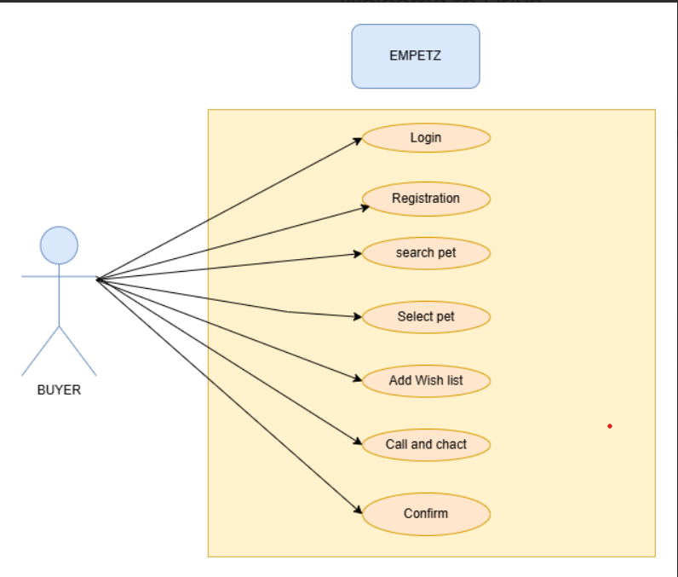

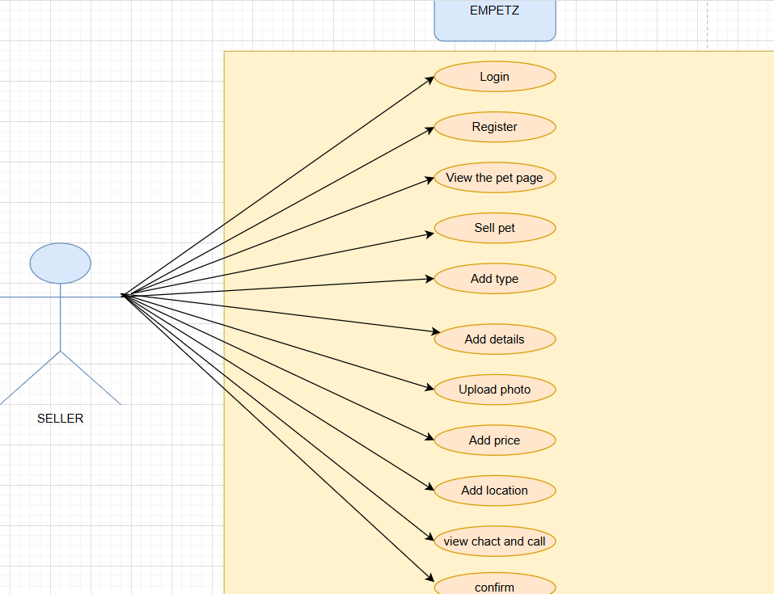

**User stories**

**Buyer**

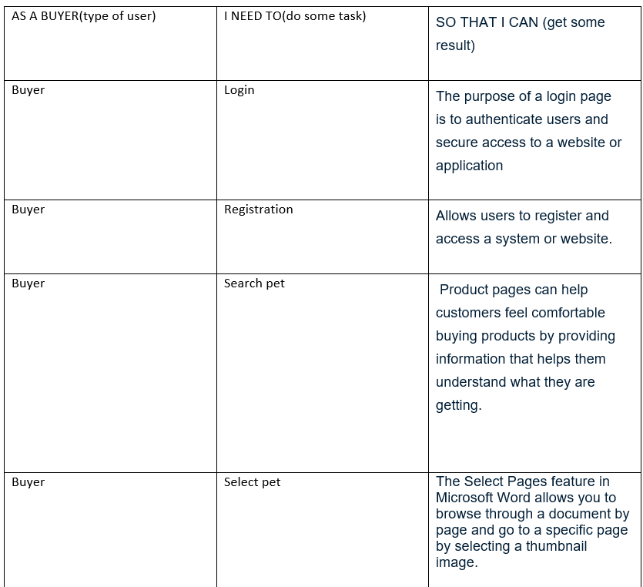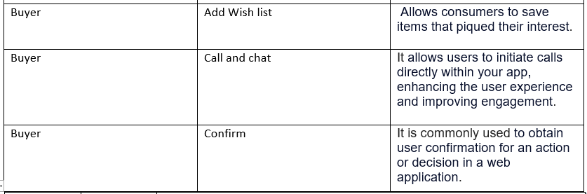

**Seller**

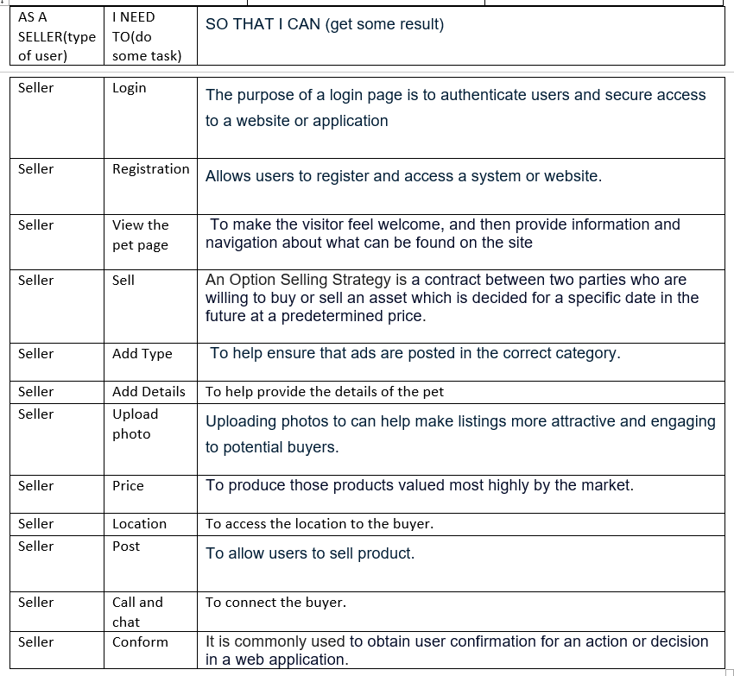

**Business Process Diagram**

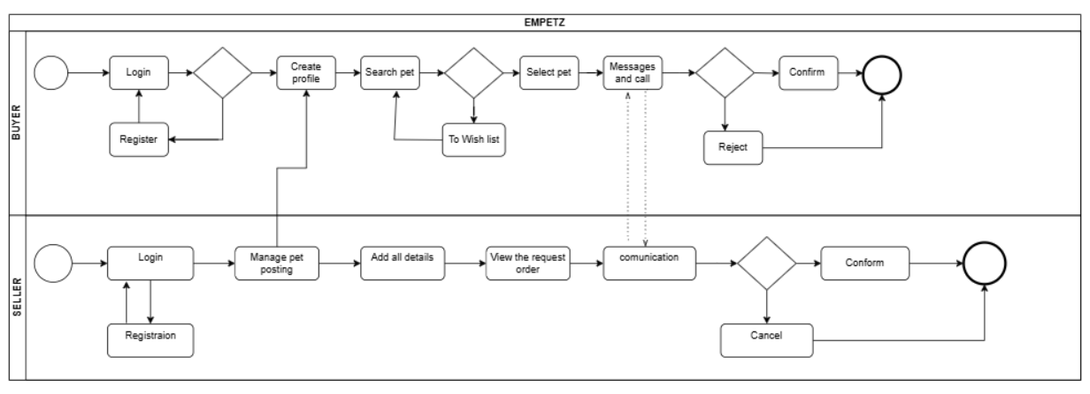

**Non Functional Requirements**

For the app **Empetz**, which is focused on buying and selling pets, the **Non-Functional Requirements (NFRs)** in the Software Requirements Specification (SRS) would include aspects like performance, reliability, security, and usability. Here’s a breakdown of each NFR category tailored for the app:

**1. Performance Requirements**

**Response Time**: The app should respond to user actions within 2 seconds on average for optimal browsing and interaction.

**scalability**: The system should handle up to 10,000 simultaneous users with minimal performance degradation.

**Load Handling**: The app should support peak load times (e.g., weekends and holidays) with minimal delay in loading images and data.

**Throughput**: Ensure the backend can process up to 500 buy/sell transactions per minute without system slowdown.

### 2. ****Reliability**** Requirements

**Uptime**: The app should have at least 99.9% uptime, allowing for planned maintenance during off-peak hours.

**Data Consistency**: Information related to pet listings, transactions, and user data must remain consistent across all modules.

**Error Handling**: The app should gracefully handle and log any system or network errors, providing feedback to the user (e.g., “Please try again later”).

**Backup & Recovery**: Implement automated daily data backups to prevent data loss in case of system failures.

### 3. ****Security Requirements****

**Authentication and Authorization**: Users must register and log in securely. Authentication protocols like OTP for phone/email verification and two-factor authentication should be supported.

**Data Encryption**: Personal data and transactions should be encrypted using SSL/TLS to ensure secure data transfer.

**Access Control**: Different user roles (admin, buyer, seller) should have specific access levels to sensitive actions and data.

**Protection Against Attacks**: Implement security measures against common attacks (e.g., SQL Injection, XSS, and DDoS) to protect the app and its users.

**Data Privacy**: Follow data privacy regulations (e.g., GDPR) to ensure that user data is stored and managed responsibly.

### 4. ****Usability Requirements****

**Intuitive Interface**: The app should have an easy-to-navigate UI with clear sections for buying, selling, and managing listings.

**Accessibility**: Follow WCAG guidelines to make the app accessible for users with disabilities.

**Responsiveness**: The app should be responsive and optimized for different devices (e.g., mobile phones, tablets, and desktops).

**User Feedback and Support**: Provide user guidance with tooltips and a “Help” section. Users should also be able to report issues or give feedback directly through the app.

**Technical Requirements**

**Empetz** has specific technical requirements to ensure it runs effectively and is compatible with various devices and operating systems. The app will be developed using **Dart** as the primary programming language for logic and backend functionality, especially because it is compatible with Flutter, which will help create a cross-platform app for both Android and iOS. **HTML** and **CSS** will be utilized for any web-based components, ensuring a responsive and visually appealing interface for users who access **Empetz** through a browser.

The development environment will use **Visual Studio Code**, a versatile platform that supports Dart, HTML, and CSS, and provides extensive plugins and debugging tools tailored to cross-platform development. In terms of **software dependencies**, **Empetz** will depend on Flutter libraries for UI components and animations, while any server-side requirements, such as databases, may require compatible plugins or SDKs to communicate with the app.

**Hardware compatibility requirements** dictate that **Empetz** should run smoothly on devices meeting minimum specifications, including a recent version of Android or iOS. Additionally, **Empetz** will need cloud services or a dedicated server infrastructure for backend operations like data storage, user authentication, and payment processing. These specific requirements ensure that **Empetz** will be robust, compatible across major platforms, and offer a seamless experience to its users.

**Conclusion**

The Software Requirements Specification (SRS) for **Empetz** outlines the essential functional and non-functional requirements for a successful pet buying and selling platform. Key functional requirements include user registration, pet listing creation, search and filtering of pets, secure messaging between buyers and sellers, and a streamlined purchasing process. Non-functional requirements focus on performance, reliability, security, and usability, ensuring the app is responsive, secure, and easy to navigate. Technical specifications cover programming languages such as Dart, HTML, and CSS, with Visual Studio Code as the primary development environment, and compatibility with Android, iOS, and web platforms. In closing, adhering closely to this SRS will support a smooth development process and create a user-centered, efficient platform for pet transactions. It is recommended to continually test **Empetz** on multiple devices and operating systems to maintain compatibility, and to prioritize data security measures, given the sensitive nature of user information and transactions.